This document is to outline the demographic we intend to develop a game for.

**Mid-Core Gamers**

As a team we have decided to develop our game for the mid core games, this is because “*Mid-Core arranges their gaming around their daily schedule”* (Mason 2013). From within this market we would like to target young males between 13-24, the top three primary motivations for male games is;

1. Completion
2. Destruction
3. Completion

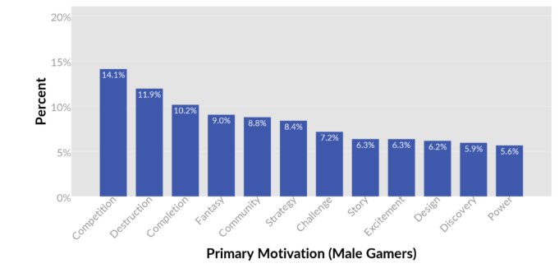

Although we are aiming to create a cooperative experience we will be focusing on destruction and completion. However, we will be trying to implement some form of competition like “Raiders of the Lost Island” Island, R. (2018).

Completion is the most Low-Risk, High-Reward motivation *“Completion is always in the top 3. In this sense, Completion is a very low-risk, high-reward* motivation.” Quantic Foundry. (2016).

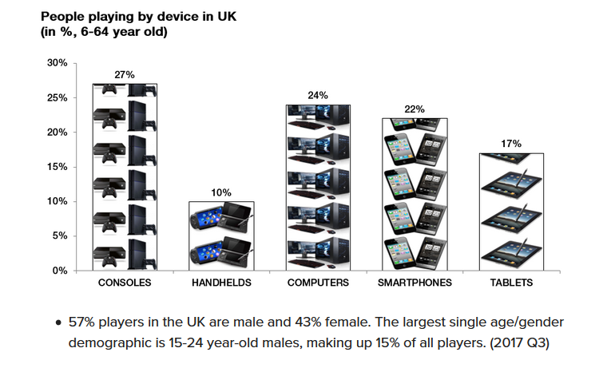

We are planning to release initially on Windows PC with 24% of the market of people playing games in the UK between the ages of 6-64. After the MVP release on Windows PC we hope to publish a version of the game on console (Microsoft Xbox One, Sony PlayStation 4) and the hybrid console-handheld device the Nintendo Switch.

We aim to release our game in the UK initially but could spread into other English-speaking regions if successful in the UK. Consumers education levels will not affect who is able to play the game, they will just need to be able to read and know English to understand the game.

Island, R. (2018). *Raiders of the Lost Island by Alexandru Simion*. [online] itch.io. Available at: https://xelanoimis.itch.io/raidersofthelostisland [Accessed 1 Nov. 2018].

#### Quantic Foundry. (2016). *7 Things We Learned About Primary Gaming Motivations From Over 250,000 Gamers*. [online] Available at: https://quanticfoundry.com/2016/12/15/primary-motivations/ [Accessed 1 Nov. 2018].

#### Gamasutra.com. (2018). *Defining mid-core games and why they matter*. [online] Available at: https://www.gamasutra.com/blogs/MaciejBiedrzycki/20171115/309666/Defining_midcore_games_and_why_they_matter.php [Accessed 1 Nov. 2018].

#### WePC.com. (2018). *2018 Video Game Industry Statistics, Trends & Data - The Ultimate List*. [online] Available at: https://www.wepc.com/news/video-game-statistics/ [Accessed 1 Nov. 2018].

#### Magmic. (2018). *Demographic Breakdown of Mobile Gamers | Magmic*. [online] Available at: http://developers.magmic.com/demographic-breakdown-casual-mid-core-hard-core-mobile-gamers/ [Accessed 1 Nov. 2018].

#### Ukie.org.uk. (2018). [online] Available at: https://ukie.org.uk/sites/default/files/UK%20Games%20Industry%20Fact%20Sheet%20October%202018.pdf [Accessed 1 Nov. 2018].